Stegaganography
*Note: Sub-titles are not captured in Xplore and should not be used

Muhammad Hassaan Ghazali
ID: 334129
mghazali.bee20seecs@seecs.edu.pk
SEECS
NUST
Islamabad, Pakistan
line 1: Muhammad Ali Farooq
ID:
mafarooq.bee20seecs@seecs.edu.pk
SEECS
NUST
Islamabad, Pakistan
Saad Bakhtiar
ID:
sbakhtiar.bee20seecs@seecs.edu.pk
SEECS
NUST
Islamabad, Pakistan

Abstract— This project focuses on the implementation of steganography techniques for secure communication. Using MATLAB, various methods such as LSB encoding and Encrypt and Scatter are employed to hide information within cover media, including images and audio files. The project explores the encryption and decryption processes involved, and presents practical examples of steganographic applications to demonstrate the effectiveness of the implemented techniques.
Keywords—steganography, MATLAB, encryption

Introduction
Steganography, the art of concealed communication, has been used since ancient times to hide sensitive information within seemingly innocuous cover objects. This intriguing field of study focuses on the covert transmission of data through the seamless integration of secret messages within digital media, such as images, audio files, or even text. By employing various techniques like LSB (Least Significant Bit) substitution and spread spectrum modulation, steganography allows for the secure exchange of information while evading detection. This project report delves into the intricacies of steganography, exploring its historical significance, modern applications, underlying principles, and the challenges it presents in today's digital landscape

EXPLANATION OF CODE
The code has been divided into multiple files for encapsulation and ease of debugging. We provide a step by step description and explanation of the function of each file.

Main.m File
This MATLAB code presents a user interface for steganography implementation. It allows the user to choose a cover format (text, audio, or image) and a hidden message format (text or image). Depending on the chosen formats, the code proceeds with encryption and decryption processes. For text hidden in audio, the user enters the message and it is encrypted and decrypted using functions for audio steganography. Similarly, for text hidden in an image, the message is encrypted and decrypted using functions for image steganography. Lastly, for image hidden in an image, the user provides the hidden image and the number of bits for encryption, and the code performs encryption and decryption using LSB substitution method.

Text_in_audio_encrypt.m
The provided MATLAB code defines a function, `text_in_audio_encrypt`, that implements steganography by embedding a text message into an audio file. The code begins by reading and extracting a portion of the input audio file. The message is converted to its binary representation, and the least significant bit of each audio sample is modified to match the corresponding bit in the message. The modified audio is played back to confirm the embedding, and the function returns the resulting audio as the output. Overall, this code demonstrates the process of hiding text within an audio file using LSB modification, enabling secure communication.

Text_in_image_decrypt.m
The provided MATLAB code contains a function called `text_in_image_decrypt` that aims to decrypt a hidden text message from an image. It takes two input arguments: `chars`, representing the number of characters in the hidden text, and `output`, which corresponds to the image containing the hidden message.

The code works by iterating through each pixel of the image and extracting the least significant bit (LSB) from the pixel values. These LSBs are stored in an array called `extracted_bits`. The extraction process continues until either all the bits of the hidden message have been obtained or all the pixels in the image have been processed. The extracted bits are then reshaped into a matrix, with each column representing the bits of a single character. By multiplying this matrix with a predefined array of powers of 2, the binary representation of each character is converted into its corresponding ASCII value. Finally, the resulting characters are concatenated to form the decrypted hidden text, which is displayed as the output of the function.

Text_in_audio_decrypt.m
The provided MATLAB code defines a function called `text_in_audio_decrypt` that aims to decrypt a hidden text message from an audio file. The function takes two input arguments: `chars`, representing the number of characters in the hidden text, and `audio_output`, which corresponds to the audio file containing the hidden message.

The code begins by extracting the least significant bit (LSB) from each audio sample in the file. These LSBs are stored in an array called `extracted_bits`. The extraction process continues until either all the bits of the hidden message have been obtained or all the samples in the audio file have been processed.

Next, the binary representation of the extracted bits is reshaped into a matrix with 8 rows and a number of columns equal to `message_length/8`. Each column represents the bits of a single character in the hidden text. By multiplying this matrix with a predefined array of powers of 2, the binary representation of each character is converted into its corresponding ASCII value. Finally, the resulting characters are concatenated to form the decrypted hidden text, which is displayed as the output of the function.

In summary, the MATLAB code employs the LSB extraction technique to decrypt a hidden text message from an audio file. By iterating through the audio samples, extracting the LSBs, converting them to binary, and then converting the binary to ASCII characters, the original hidden message can be reconstructed and revealed.

Text_in_image_encrypt.m
The provided MATLAB code implements text encryption using image steganography. The code takes an input image, resizes it, and converts it to grayscale. It then extracts the LSBs of the pixels and replaces them with the binary bits of a given message. By iterating through each pixel and comparing it with the corresponding bit in the message, the code modifies the pixel values to embed the message. The resulting steganographic image is displayed alongside the original input image.

To achieve this, the code converts the message characters to their ASCII values and then converts those values to binary representation. It reshapes the binary message into a suitable format for embedding. The code traverses through the image pixels and performs bit embedding by comparing and modifying the LSBs. Finally, the code visualizes the steganographic image and the original input image for comparison.

In summary, the MATLAB code utilizes image steganography to encrypt a text message by embedding its binary representation into the LSBs of the pixels in an input image. This technique allows for hiding the message within the image, making it visually indistinguishable from the original image.

Image_in_image_lsb_encrypt.m
The provided MATLAB code implements image steganography by embedding a "hidden" image into a "cover" image using the Least Significant Bit (LSB) technique. The code takes the "cover" image and "hidden" image as inputs, resizes them to the same size, and checks if the specified number of LSBs (`n`) is within the valid range of 1 to 7.

If `n` is valid, a bitmask is created to clear the `n` least significant bits of the pixel values in the "cover" image. The LSBs of the "cover" image are then cleared using the bitmask, and the "hidden" image is shifted to align its significant bits with the cleared LSB positions. The resulting pixel values are combined using bitwise OR, producing the steganographic image. Finally, the steganographic image is displayed.

In summary, the MATLAB code allows for hiding one image within another using LSB steganography. By manipulating the LSBs of the pixel values, the "hidden" image is embedded into the "cover" image, resulting in a steganographic image that visually appears similar to the original cover image while concealing the hidden image.

Image_in_image_lsb_decrypt.m
The provided MATLAB code is a decryption function that utilizes the least significant bit (LSB) technique to extract hidden information from an encrypted image. The function takes two parameters: `n`, which represents the number of bits used for encryption, and `Steganog_image`, the image containing the hidden data.

During the decryption process, the code first shifts the `Steganog_image` to the left by `8 - n` bits. This aligns the encrypted bits to the rightmost position, allowing for extraction. The `bitand` function is then applied to the shifted image, in combination with `255`, which is the binary representation of the decimal value `11111111`. This operation extracts the rightmost `n` bits from each pixel by performing a bitwise AND between the shifted image and `11111111`.

Finally, the resulting extracted image is displayed using the `imshow` function, and it is given the title 'Extracted Image'. Overall, this code decrypts an image by extracting the hidden information encoded in the LSBs of the encrypted image, and it displays the extracted image for further analysis or visualization.

Results

Text in Image
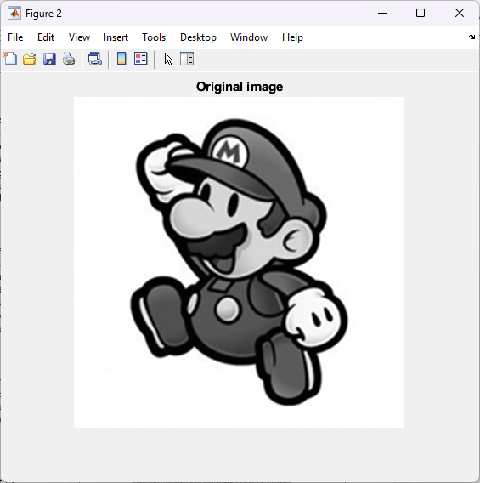
Figure 1 Original Image
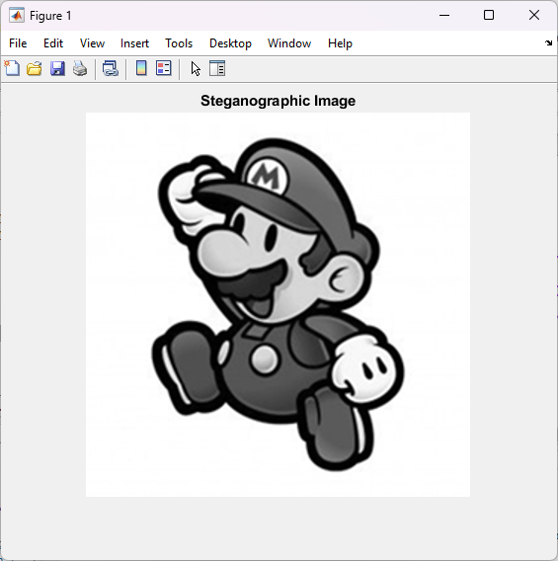
Figure 2 Stenographic Image
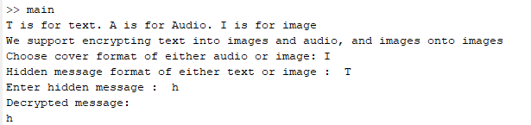
Figure 3 Output Console
Here we can see after embedding text onto an image using LSB, the altered image is identical to the original one to the human eye.

Image in Image
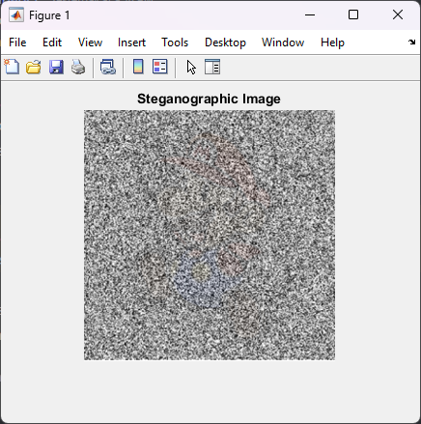
Figure 4 Stenographic Image
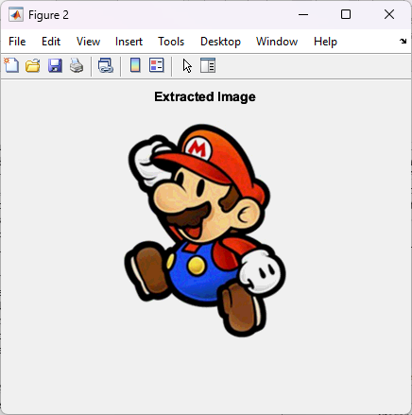
Figure 5 Extracted Image
Here we see how the extracted image is concealed within the stenographic image and is clearly not detectable by the human eye.

Conclusion
To conclude, we have seen an implementation of a basic LSB scheme for steganography. A basic demonstration is given and shows the potential of this encryption scheme. Further work has also been done on top of this by adding scrambling, using SNR etc.

